# PMSM MODEL AND SIMULATION

## Objectives

The main objective of this lab is to model and simulate a PMSM in a EV application.

In this lab, you will have to modify the model of the EV already implemented and substitute the DC motor by a PMSM. Then, the system will have to be simulated in different conditions.

## Questions

The EMRAX motor 188, low voltage (<https://emrax.com/wp-content/uploads/2020/03/manual_for_emrax_motors_version_5.4.pdf>) is supposed to be used for this application.

Motor parameters:

|  |  |
| --- | --- |
| **Parameter** | **Value** |
| Rs | 0,8 m |
| Ld | 5,4 H |
| Lq | 6,0 H |
| Lambdam | 0,072 Vs/rad |
| Pole pairs | 10 |

Modify the model of the vehicle for a PMSM. Remember that you have also to modify the controller and the inverter.

1. Paste a picture of the implementation of the model of the PMSM, electric part, and electromechanical conversion part.

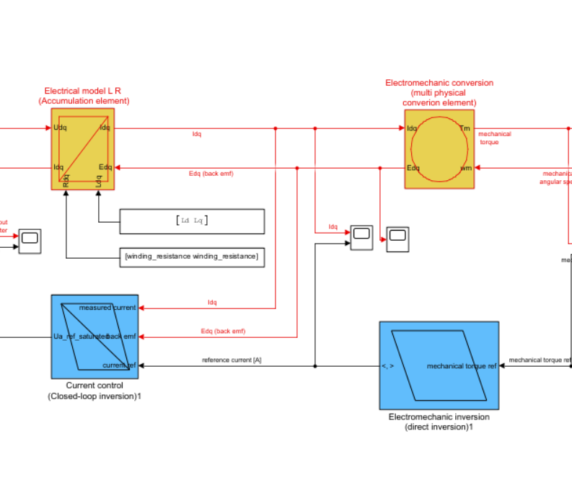

Figure 1, implementation of PSM motor, electrical and electrotechnical and its inversion’s blocks

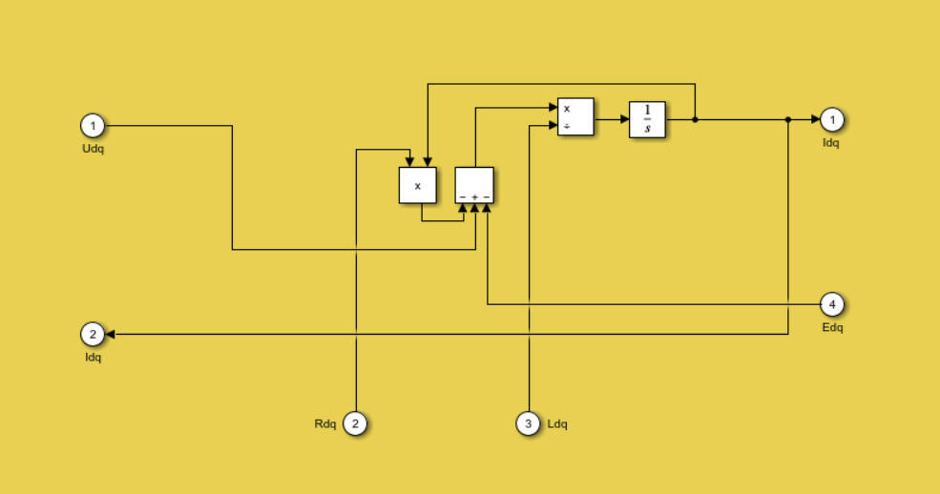

Figure 2, electrical model L R block

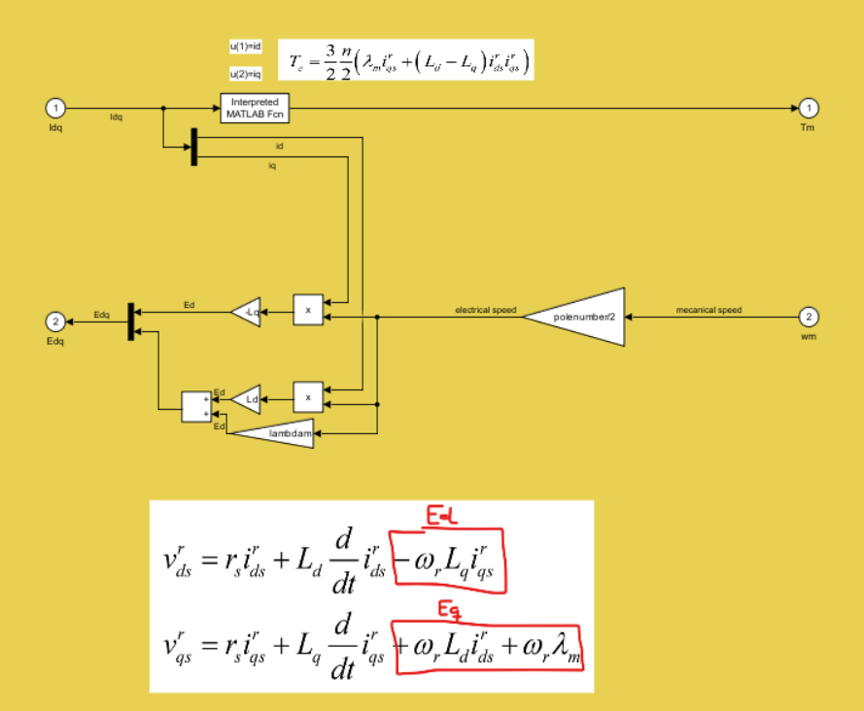

Figure , electromechanic conversión block

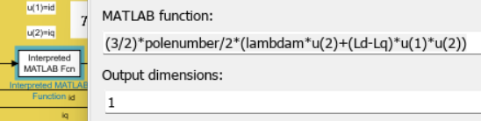

Figure 4, detail of interpreted matlab function for mechanic torque calculation from Idq

1. Paste an image of the implementation of the controller.

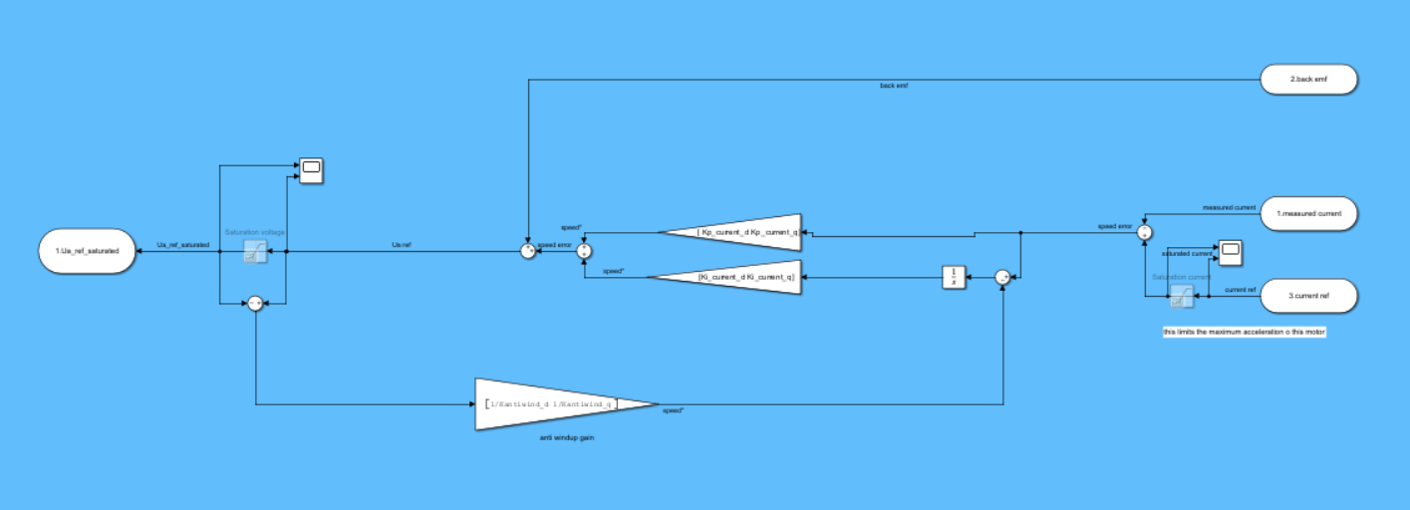

Figure 5, current control with current and voltage saturators disabled (antiwindup also disabled)

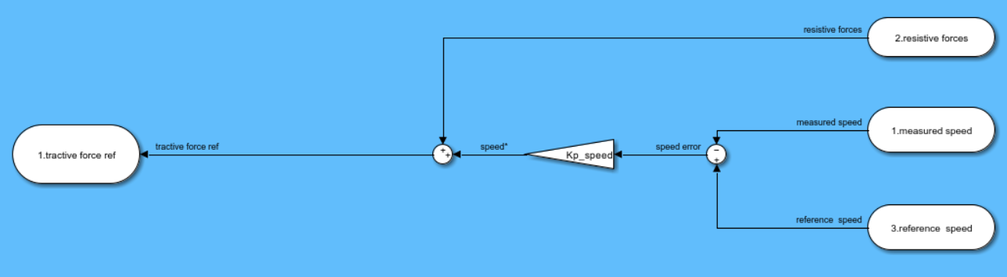

Figure 6, speed control, no saturation

1. Paste an image of the implementation of the modulator and the inverter..

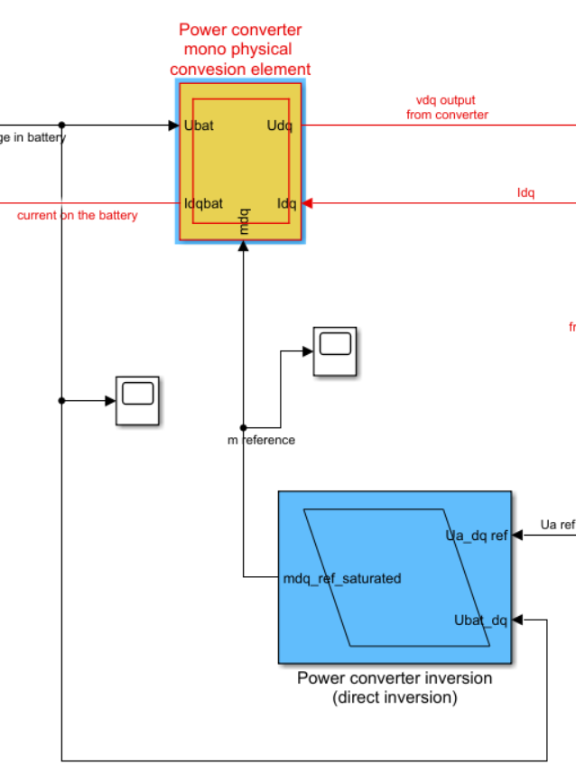

Figure 7, power converter block and its inversion

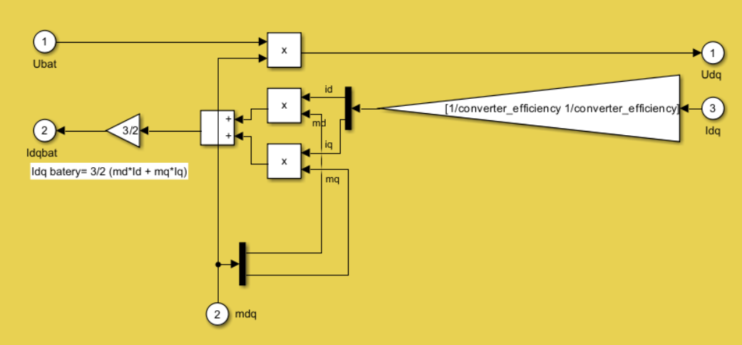

Figure 8, power converter block, from DC voltage to d-q transformed voltages

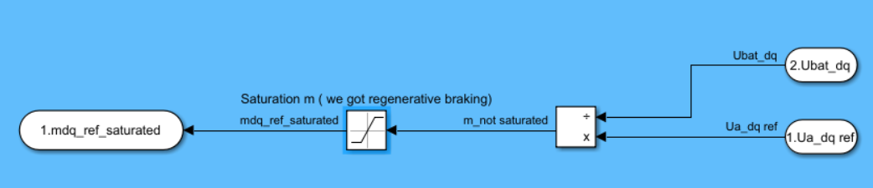

Figure 9, power converter inversión, to calculate duty cycle m from voltages  
(saturated from 1 to -1)

1. Explain and compute the tuning of the controller.

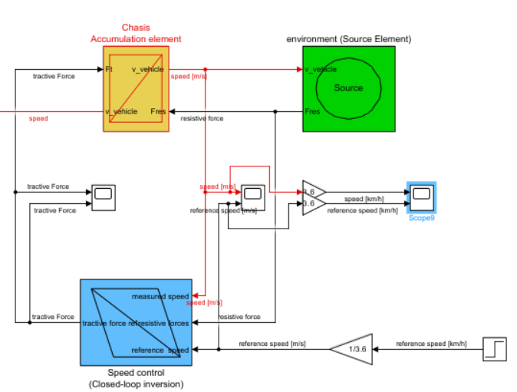

Figure 10, connection for the speed control tunning.

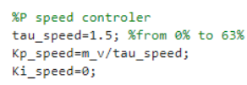

Figure 11, parameters for the slow speed control loop.

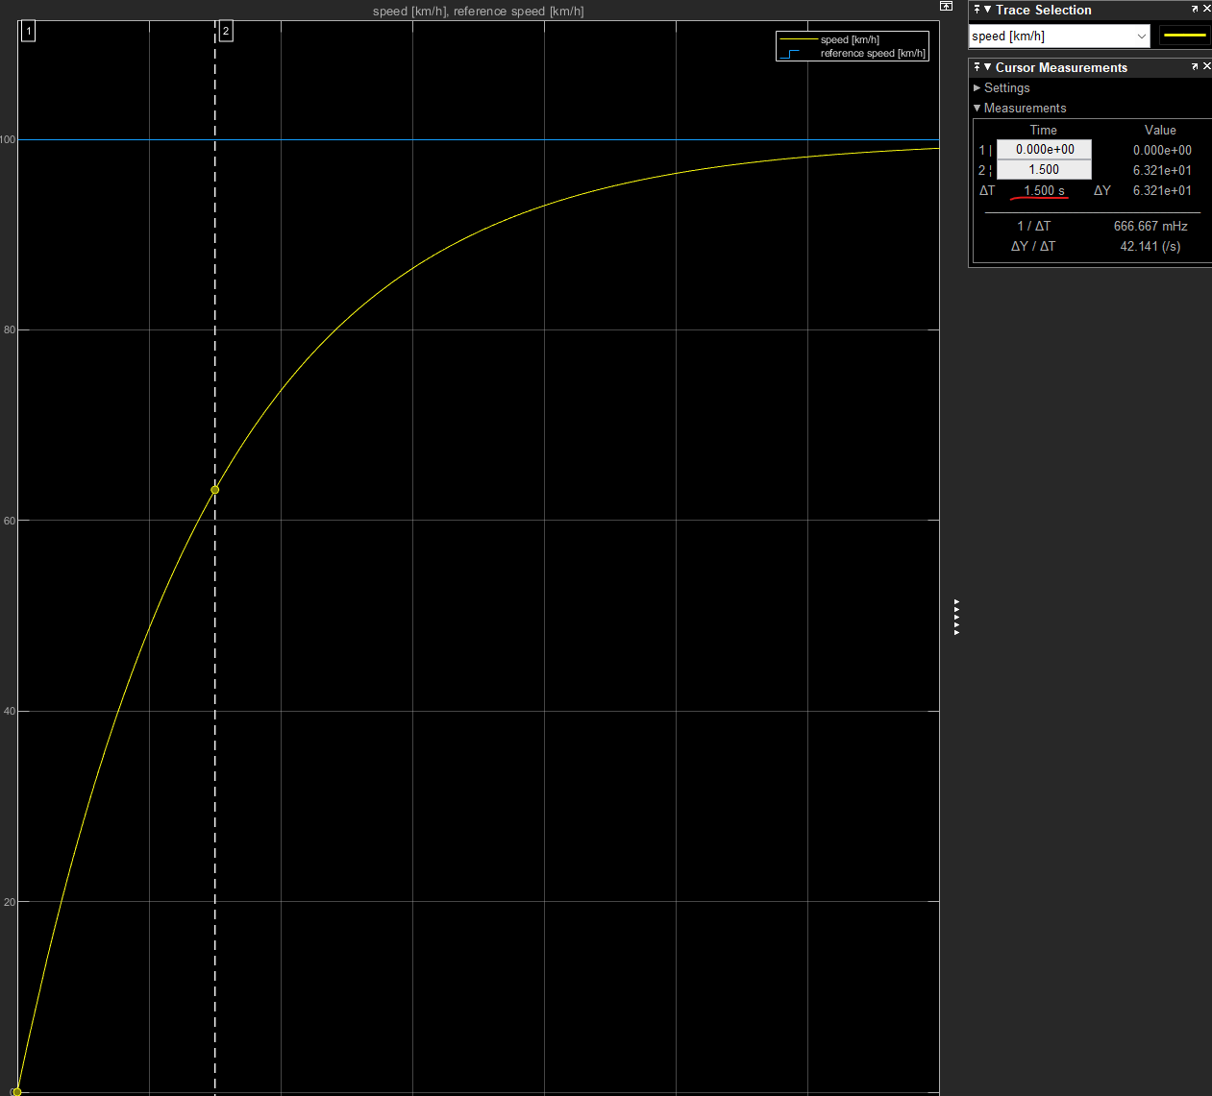

Figure 12, with a step of 100Km/h we reach 63km/h in exactly 1,5second, as intended.

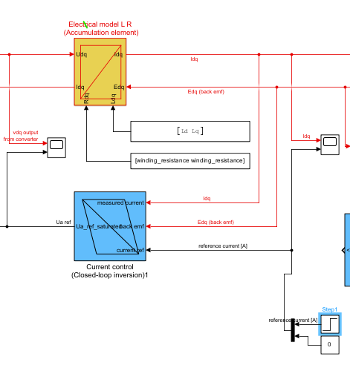

Figure 13, connection for the current loop tunning

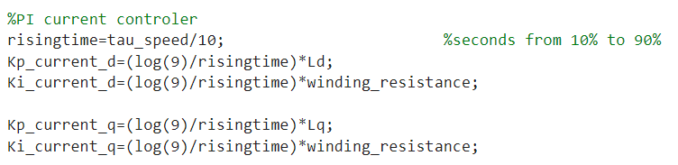

Figure 14, parameters for the fast current control loop (loop speed is 10 higher to correctly decouple both controls)

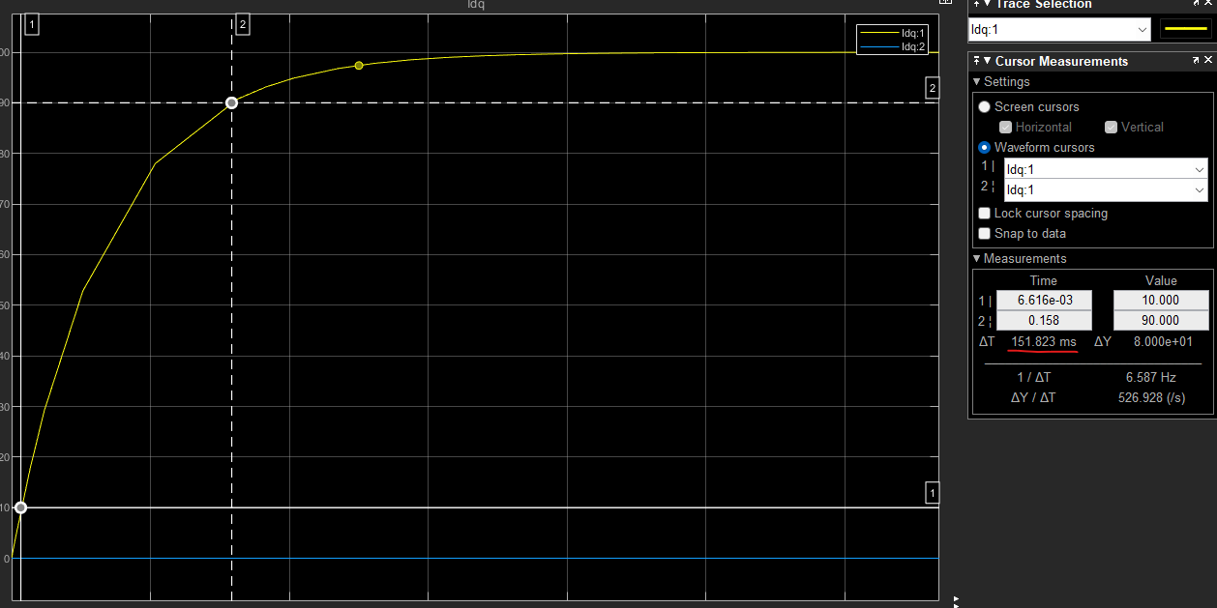

Figure 15, step response to 100Amps, rising time = 0.15s , matching our intended design

For the required performance,

|  |  |
| --- | --- |
| **Performance target** | **Target value** |
| 0 to 100 km/h | 7 s |
| Maximum speed | 120 km/h, at 0% grade |
| Grade at 80 km/h | 7,2 % |
| Maximum grade | 33 %, at 5 km/h |
| NEDC cycle | - |

1. Paste plots of voltage/current/vehicle speed showing that it can be fulfilled and explain why.

Reference ramp: the vehicle is able to reach 100Km/h in 7 seconds, with current and voltages within range.

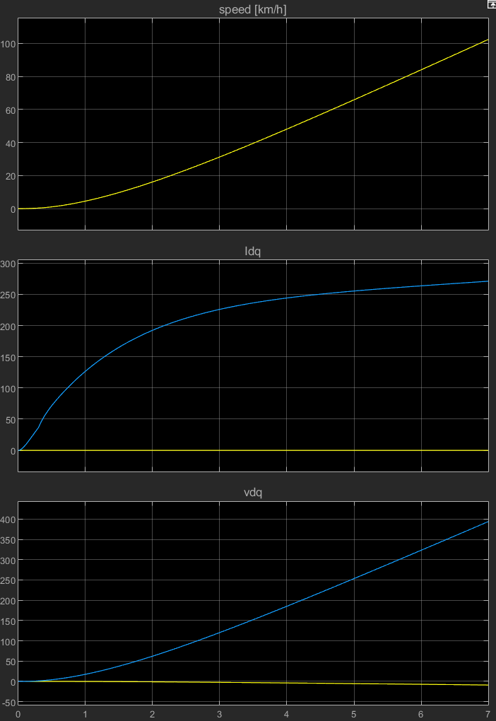

Figure 16, ramp speed response 100Km/h

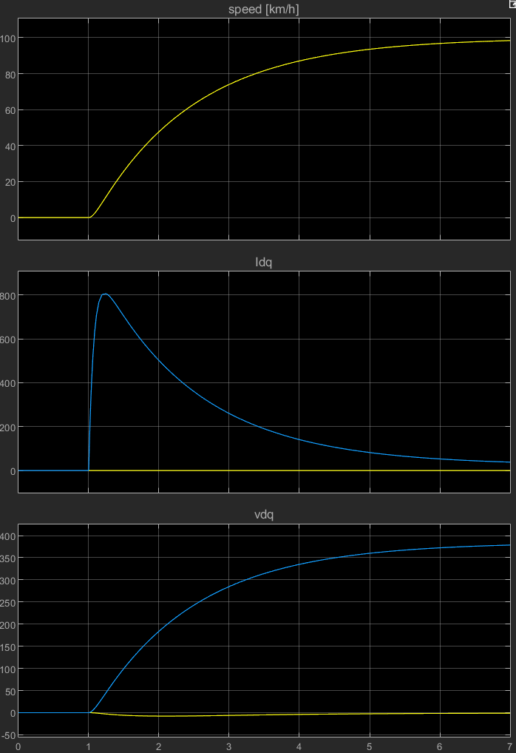

Figure 17, step response 100Km/h (temp current limit of the motor 800amps is almost reached)

The maximum speed is defined by the max 800V from the battery and the max of m=1 from the converter so the vehicle will reach 208Km/h

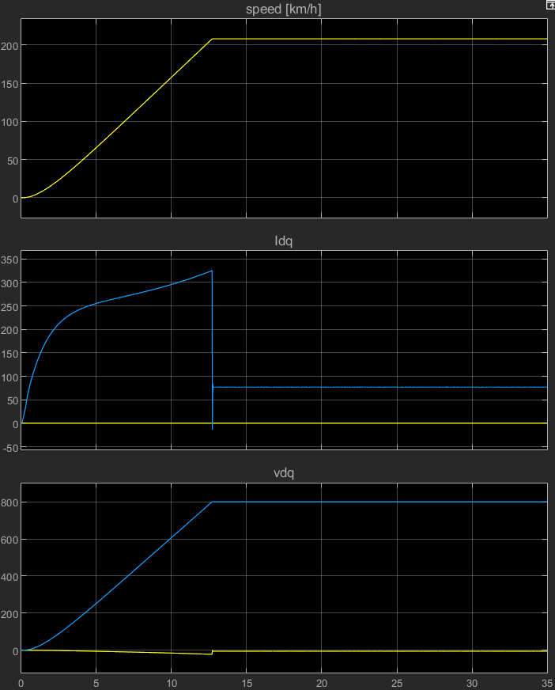

Figure 18, showing maximum speed of 208km/h for 0% slope  
Current peaks at 325Amps

Increasing the slope makes the vehicle reach its max speed slower and demands more current.

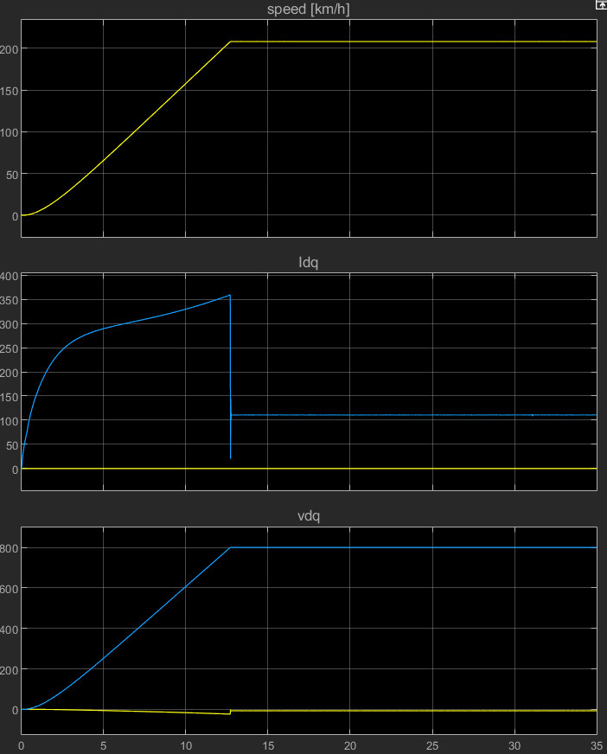

Figure 19, showing maximum speed of 208km/h for 7,2% slope  
Current peaks at 355Amps

Increasing the slope even more makes the vehicle reach its max speed slower and demands more current.

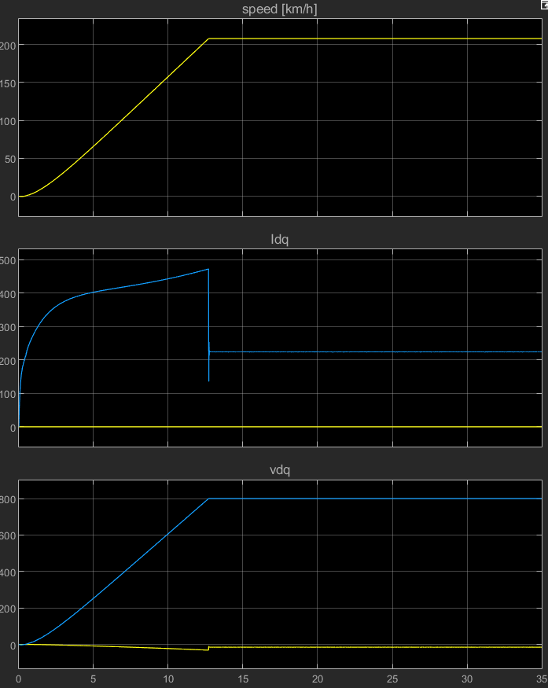

Figure 20, showing maximum speed of 208km/h for 33% slope  
Current peaks at 470Amps

The vehicle follows the NEDC cycle flawlessly.

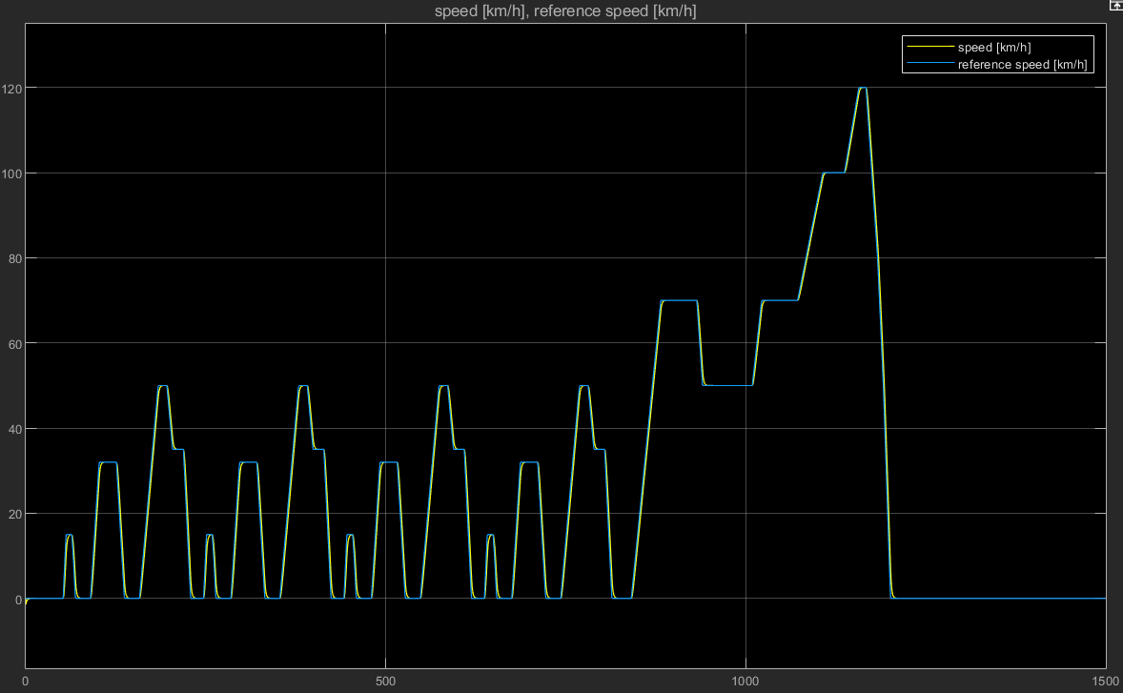

Figure 21, speed reference and real speed from NEDC profile

Currents are well within motor limits (400amps) and Voltages surpass the 110V recommended limit of the motor, but we are not limiting the voltage in our control.

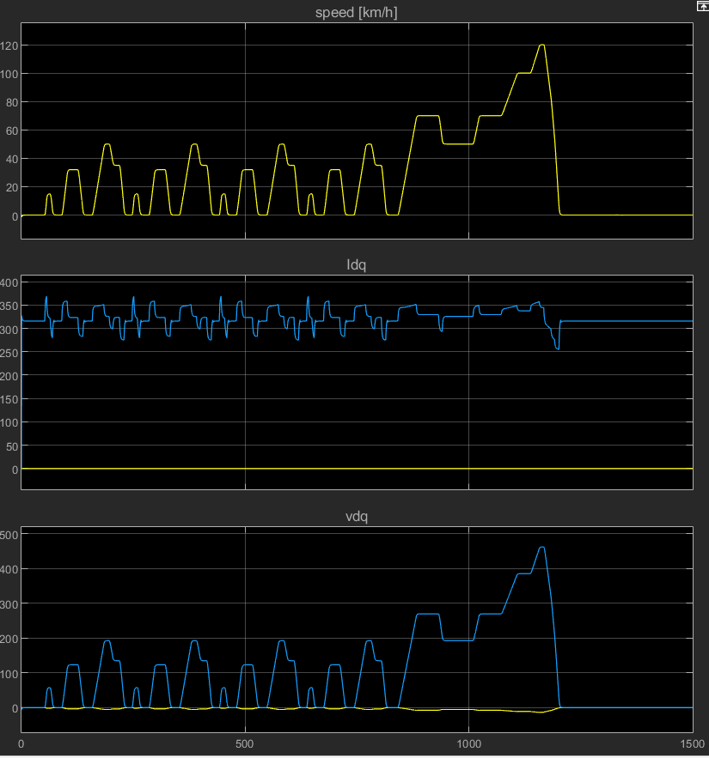

Figure 22, resulting speed Current and voltage from the NEDC profile.